2018/11/15

**安裝環境與版本：** RHEL server 7.5 x86_64 JBoss EAP 7.1  standalone server  
**1. 　安裝**

在此介紹文字介面  JAR 安裝程序:

先取得  JAR 安裝程序檔案   jboss-eap-7.1.0-installer.jar

以下安裝流程修改： installation path, Admin username, Admin password 其他用預設值

紅色字為輸入部份

[root@jbs01 ~]# java -jar jboss-eap-7.1.0-installer.jar -console

Select language :

0: eng

1: chn

2: deu

3: fra

4: jpn

5: por

6: spa

Please choose [0] :

**0**

END USER LICENSE AGREEMENT

..........

（略）

..........

press 1 to continue, 2 to quit, 3 to redisplay.

**1**

Select the installation path:  [/root/EAP-7.1.0]

/opt/jboss-eap-7.1

press 1 to continue, 2 to quit, 3 to redisplay.

**1**

Select the packs you want to install:

1    [x] [Required]      [Red Hat JBoss Enterprise Application Platform] (27.13 MB)

2    [x]                 [AppClient] (39.29 KB)

3    [x]                 [Docs] (10.89 MB)

4    [x] [Required]      [Modules] (167.32 MB)

5    [x] [Required]      [Welcome Content] (2.11 MB)

Total Size Required: 207.49 MB

Press 0 to confirm your selections

Please select which packs you want to install

**0**

Pack Selection Done

press 1 to continue, 2 to quit, 3 to redisplay.

**1**

Create an Administrative User

This user will be added to the host container's management realm for administrative purposes. It can be used to access the management console, the management CLI, or other applications secured in this realm.

For minimal security, the password should be at least eight characters long, with one alphabetic character, one digit, and one non-alphanumeric symbol excluding "&".

Admin username: [admin]

jbossadmin

Admin password: []

********

Confirm admin password: [********]

********

press 1 to continue, 2 to quit, 3 to redisplay.

**1**

[ Starting to unpack ]

[ Processing package: Red Hat JBoss Enterprise Application Platform (1/5) ]

[ Processing package: AppClient (2/5) ]

[ Processing package: Docs (3/5) ]

[ Processing package: Modules (4/5) ]

[ Processing package: Welcome Content (5/5) ]

[ Unpacking finished ]

Configure Runtime Environment

There are several additional options for configuring Red Hat JBoss Enterprise Application Platform now that the server has been installed. Each option can be individually chosen, and will be configured in the order displayed upon pressing "Next". What would you like to do now?

0  [x] Perform default configuration

1  [ ] Perform advanced configuration

Input Selection:

**0**

press 1 to continue, 2 to quit, 3 to redisplay.

**1**

[ Starting processing ]

Starting process Logging installation information (1/3)

IzPack variable state written to /opt/jboss-eap-7.1/installation/InstallationLog.txt

Starting process Adding admin user (2/3)

Starting process Cleanup extraneous folders and temporary files (3/3)

Installation has completed successfully.

Application installed on /opt/jboss-eap-7.1

Would you like to generate an automatic installation script and properties file? (y/n) [n]:

**n**

[ Console installation done ]

[root@jbs01 ~]#

到此基本安裝完成

**2. 　 設定  standalone.xml**

EAP_HOME 用於表示 JBoss EAP 安裝的路徑

1.編輯檔案︰EAP_HOME/standalone/configuration/standalone.xml

剛安裝完成預設︰

493行

<inet-address value="${jboss.bind.address.management:127.0.0.1}"/>

496行

<inet-address value="${jboss.bind.address:127.0.0.1}"/>

將此二行  127.0.0.1 修改為本機 IP Address，或改為 0.0.0.0 (所有 IP 皆接聽)

**3. 　設定  RHEL server firewall**

設定 RHEL server firewall 接受 JBoss EAP  預設的 tcp port 8080, 9990

firewall-cmd --add-port=8080/tcp --add-port=9990/tcp --add-port=8443/tcp

firewall-cmd --add-port=8080/tcp --add-port=9990/tcp --add-port=8443/tcp --permanent

**4. 　啟動  standalone server**

EAP_HOME 用於表示 JBoss EAP 安裝的路徑

啟動  standalone server

EAP_HOME/bin/standalone.sh

例如︰

/opt/jboss-eap-7.1/bin/standalone.sh

console 會有即時訊息，並等待服務啟動完成，下為啟動完成訊息

15:21:36,026 INFO [org.jboss.as] (Controller Boot Thread) WFLYSRV0025: JBoss EAP 7.1.0.GA (WildFly Core 3.0.10.Final-redhat-1) started in 17816ms - Started 292 of 553 services (347 services are lazy, passive or on-demand)

以其他  console 檢查 java 執行情況

netstat -ntulp | grep java

[root@jbs01 log]# netstat -ntulp | grep java

tcp 0 0 0.0.0.0:9990 0.0.0.0:* LISTEN 6622/java

tcp 0 0 0.0.0.0:8080 0.0.0.0:* LISTEN 6622/java

tcp 0 0 0.0.0.0:8443 0.0.0.0:* LISTEN 6622/java

所以目前服務已使用 3 個 port

以 browser 開啟  http://x.x.x.x:8080 可以看到如下︰

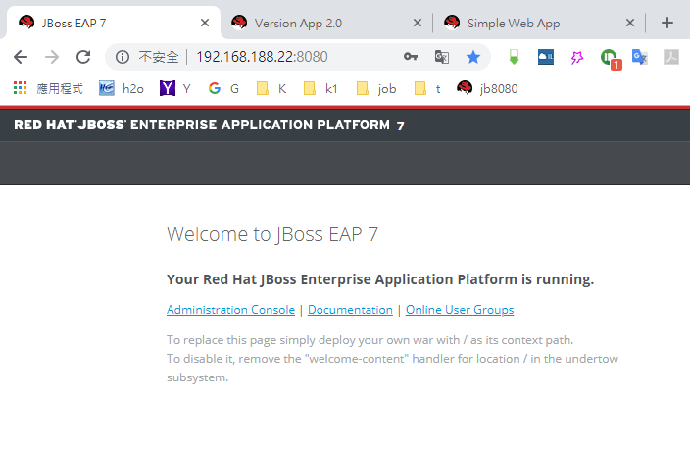

點選其上的  Administration Console 連結

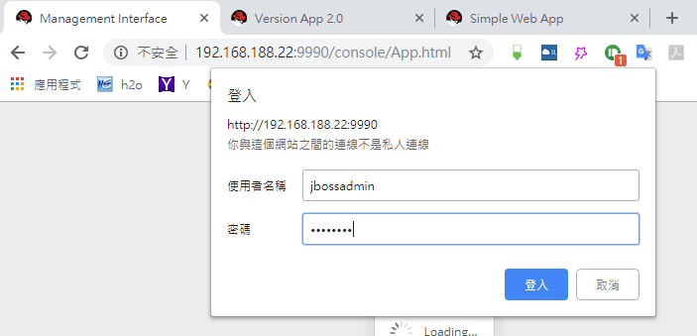

登入  Administration Console 使用安裝時設定的  Admin username,  password

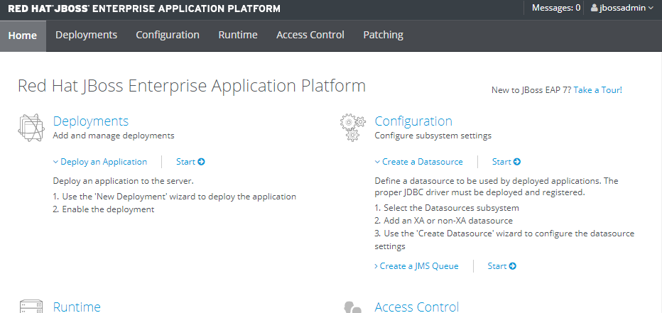

**5. 　停止  standalone server**

在啟動的  console 按下  ctrl + c 就可以停止

**6. 　 Deploy Applications to  standalone server**

**方法1︰** Administration Console

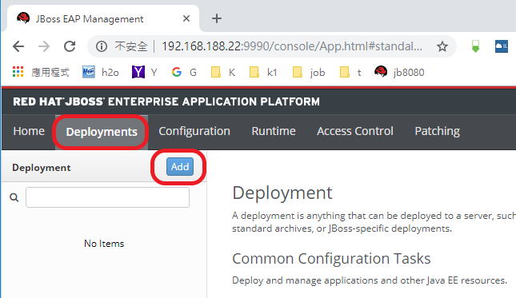

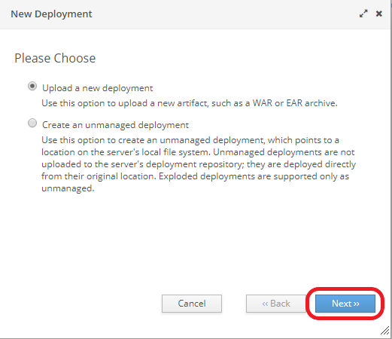

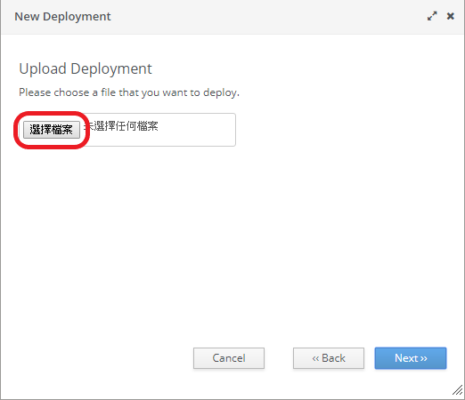

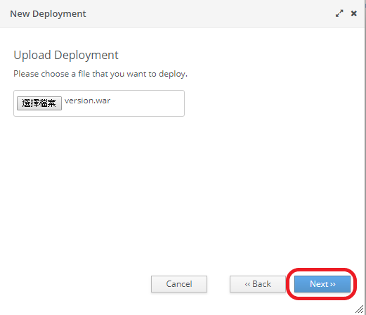

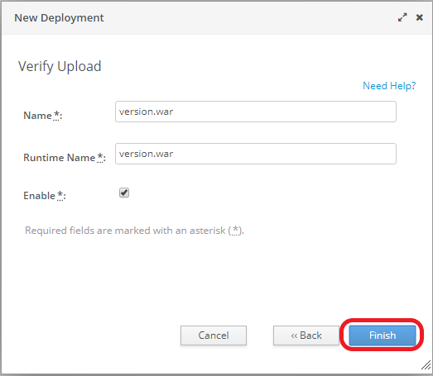

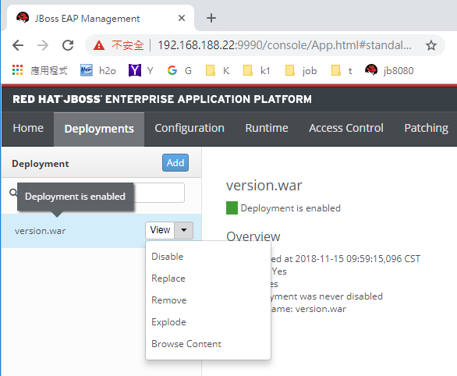

Deploy 時，在啟動服務的 console 會有即時訊息

09:59:24,462 INFO  [javax.enterprise.resource.webcontainer.jsf.config] (ServerService Thread Pool -- 67) Initializing Mojarra 2.2.13.SP4  for context '/version'

09:59:26,204 INFO  [org.wildfly.extension.undertow] (ServerService Thread Pool -- 67) WFLYUT0021: Registered web context: '/version' for server 'default-server'

09:59:26,373 INFO  [org.jboss.as.server] (External Management Request Threads -- 6) WFLYSRV0010: Deployed "version.war" (runtime-name : "version.war")

Deploy  version.war 預設 URL 路徑如下 (相對檔名，不含副檔名)

以 browser 開啟  http://x.x.x.x:8080/version

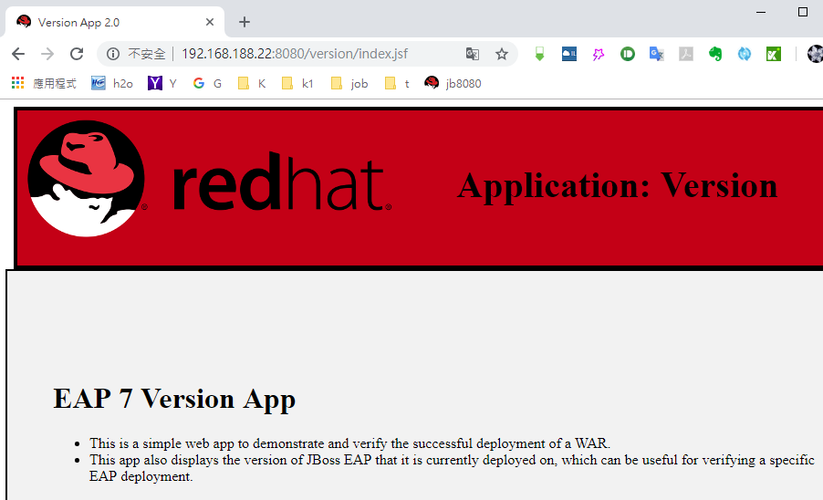

**方法2︰**Deploy applications using the CLI

進入 CLI

/opt/jboss-eap-7.1/bin/jboss-cli.sh --connect

看所有  deployment  資訊：

deployment-info

Deploy：

deploy /root/version.war

disable：

deploy version.war -f --disabled

enable :

deploy version.war -f --enabled

undeploy :

undeploy version.war

**方法3︰**Deploy applications with the file system deployer

EAP_HOME 用於表示 JBoss EAP 安裝的路徑

Deploy:

cp  version.war  EAP_HOME/standalone/deployments

Redeploy:

如果  EAP_HOME/standalone/deployments/version.war 已存在

touch  EAP_HOME/standalone/deployments/version.war.dodeploy

undeploy :

rm  EAP_HOME/standalone/deployments/version.war.deployed

**7. 　standalone server log**

EAP_HOME 用於表示 JBoss EAP 安裝的路徑

log 位於

EAP_HOME/standalone/log/server.log